Level 1 Trophy Training 
- Win with King + Rook + Rook versus King
- Win with King + Queen versus King
Mate is possible at the side of the board only. A key position is:
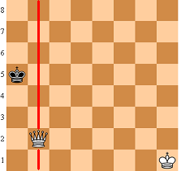
Don’t let the black King escape from the side of the board – bring your King close to the black King for the mate. When the Queen is close to the black King always check for stalemate!
- Show an opening plan:
1) one pawn in the center
2) play knights and bishops (you’ll need to move a second pawn to free a bishop)
3) castle
4) move the queen to connect the rooks
- Defend against the “4 move checkmate"
