Level 3 Trophy Training 
Win with King+Bishop+Bishop versus King
A key position is:
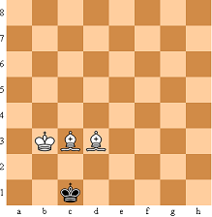
When it’s White’s move White wins:
1. Be2, Kb1 2. Bd2, Ka1 3. Bf1 (wastes a move), Kb1 4. Bd3+, Ka1 5. Bc3 mate
When it’s Black move Black plays 1…,Kd1
Now, white has to make a triangle using his King to force Black into the position above.
King plus Pawn versus King with King behind the pawn
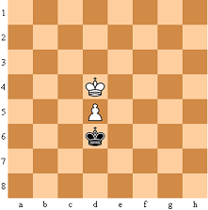
Defense: you are Black and have to keep a draw. Keep your King in front of the Pawn and King as much as possible. Don’t allow the White King to get in front of the pawn (see Level 2!)

More terminology
- Skewer: attack two more valuable pieces that are positioned in a line:
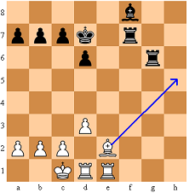
Only one rook can move away – after that you can take the other one.
- Back rank mate:
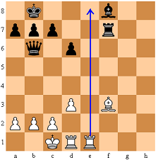
Always watch your back rank (make an escape for the King by playing ..a6 earlier).
- Double check: a check with two pieces:
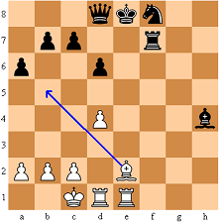
Double checks are dangerous:
- Black cannot take the piece that’s giving check (since there are two!)
- Black cannot place anything between the piece that’s giving check and the King (there are two!)
In this case the double check is also a mate!

